A SIMPLE REPORT: STUDY PLANNER
Mahesa Gita Dharma¹, Muhammad Rofiif Arifian², Nadhiffa Akilla Ramadhani³, Nurul Fatimah⁴
21867@student.stembayo.sch.id¹, 21875@student.stembayo.sch.id², 21876@student.stembayo.sch.id³, 21878@student.stembayo.sch.id⁴
SMK Negeri 2 Depok Sleman

- INTRODUCTION
Time management and academic organization are critical challenges for high school students, particularly when balancing dense theoretical coursework with complex practical laboratory assignments. To keep track of their academic responsibilities, many students still rely on conventional handwritten notes or separate mobile calendar applications. These disconnected tools lack centralized reminder systems and automated synchronization, frequently leading to disorganized priorities, task procrastination, and missed assignment deadlines. This prevalent friction in managing daily study routines is the primary reason why the developers engineered StudyPlanner as a centralized digital solution to optimize student productivity.
StudyPlanner is an integrated web application designed to consolidate academic task tracking, schedule planning, digital notes, and intelligent tutoring into a single digital workspace. Through this platform, students can manage their daily timetables, monitor homework deadlines, record class notes, and track study intervals using an integrated Pomodoro timer. When tasks or events are modified within the application, the system automatically synchronizes data with Google Tasks and Google Calendar while providing contextual academic assistance through an interactive AI chatbot.
The basic theory applied in this project is modern Web Application Development utilizing the Model-View-Controller (MVC) architecture, Cloud Application Programming Interface (API) synchronization, and direct Large Language Model (LLM) integration. In this system, the Laravel PHP framework serves as the core backend engine to process data securely and maintain relational integrity. Google Tasks API and Google Calendar API utilize the OAuth 2.0 protocol to enable secure, bidirectional cloud data exchange. Furthermore, direct AI integration connects the backend directly to Groq's high-speed inference engine (running qwen/qwen3-8b-27b) via Laravel’s HTTP client, eliminating third-party automation middleware and retaining conversational history natively within MySQL.
This project was developed over approximately two months during the 2026 academic year. The development progressed systematically through project ideation on July 20, 2026, system and database architecture design on August 10, 2026, core backend and API implementation on August 28, 2026, and functional verification testing on September 18, 2026. The project was carried out by four members of Class XII SIJA B at SMK Negeri 2 Depok Sleman under the academic guidance of project supervisor R.r Retna Trimantaraningsih, S.T.: Mahesa Gita Darma as the Project Manager, Muhammad Rofiif Arifian as the Backend & Lead Developer, Nadhiffa Akilla Ramadhani as the UI/UX & Frontend Developer, and Nurul Fatimah as the System Analyst & Technical Documentation.
The development process of StudyPlanner was executed through the Software Development Life Cycle (SDLC), incorporating requirements gathering, UI/UX prototyping, full-stack programming, and black-box verification. Through this project, StudyPlanner was built to eliminate application fragmentation, reduce academic stress, and foster independent learning habits. The platform not only simplifies academic scheduling, but also equips students with an intelligent technological ecosystem to manage their educational journey more effectively.

- METHOD/PROCEDURE
A. Project Development
The technical implementation of StudyPlanner began with requirements analysis and database modeling, where the developers analyzed student academic workflow challenges and designed a normalized MySQL relational database schema. This schema encompasses core entities including users, tasks, task_steps, schedules, school_timetables, notes, study_sessions, chat_sessions utilizing UUID primary keys for secure, decentralized identifiers, and chat_messages. With the data architecture established, the team proceeded to user interface prototyping by designing responsive wireframes characterized by a minimalist aesthetic with a deep plum, soft rose, and warm cream palette. These wireframes were translated into responsive front-end layouts leveraging Laravel Blade templates and Tailwind CSS utility classes. Following interface prototyping, core backend services were architected on Laravel’s Model-View-Controller (MVC) paradigm to enforce route protection, session management, secure credential handling, and comprehensive CRUD operations across all operational modules. External interoperability was established through Google Cloud API integration using OAuth 2.0, where the secure database storage of user access and refresh tokens enabled continuous background synchronization between StudyPlanner, Google Tasks, and Google Calendar without demanding repetitive user re-authentication, supported by automated 30-minute and 10-minute event reminder notifications. Finally, to deliver responsive and contextual study assistance, the developers engineered GroqAiService, a native backend service communicating directly with Groq’s OpenAI-compatible completions endpoint via Laravel’s HTTP client. This service dynamically assembles prompts by extracting the last 20 messages along with project-level sibling session histories directly from MySQL, delivering low-latency inference while entirely eliminating third-party automation middleware.

B. Project Usage and Testing
The operational workflow of the application commences when a student authenticates into the platform and links their Google account through the Integrations menu to activate automated background cloud synchronization. Users organize their daily academic commitments via My Tasks and the Class Schedule or Timetable; any task creation or routine modification immediately updates the MySQL database and propagates entries to Google Tasks and Google Calendar with preconfigured reminder alarms. During focused study sessions, the student activates the Pomodoro Focus Timer in the Progress module, which actively monitors long-term engagement through a Study Streak counter and a GitHub-style 53-week Activity Heatmap. Within this workflow, ticking off modular sub-task steps dynamically recalculates task progress and automatically flags the master assignment as completed across both local database records and connected Google services. For academic inquiries, students interact with StudyBot through the AI Chat interface, where ChatController persists the prompt, compiles previous conversational context, and dispatches the payload to GroqAiService for instant tutoring guidance. System verification was conducted using a dual-phase hybrid testing methodology to guarantee overall reliability. First, automated feature and integration testing was executed using Pest PHP to programmatically validate backend business logic, route access controls, database transactions, and input validation rules. Second, comprehensive manual functional black-box testing was conducted on the compiled application to evaluate end-to-end workflows without internal code inspection—confirming OAuth handshake reliability, bidirectional cloud synchronization stability, timer execution fidelity, and the contextual accuracy of the AI chatbot under real-world usage conditions.

- FINDINGS / EVIDENCE
System verification and functional black-box testing confirmed that all core modules of StudyPlanner operate reliably according to technical design specifications. All responsive web interfaces render correctly across viewport sizes, database transactions process without conflict, and external cloud integrations including bidirectional Google API synchronization and direct Groq AI services—demonstrate stable performance.

A. Functional System Verification
Black-box testing was executed across nine primary functional scenarios. The evaluation verified that every operational flow succeeded without errors:

Table 1: System Verification and Black-Box Testing Results
No. | Test Scenario / Module | Expected Result | Testing Status
1 | User Authentication | User logs in securely; session state is created and maintained | Passed
2 | Add Task (My Tasks) | New tasks are stored in MySQL and `synchronized to Google Tasks | Passed
3 | Edit Task | Modified deadlines, categories, and priority levels update successfully | Passed
4 | Delete Task | Deleted tasks are removed from the database and Google Tasks | Passed
5 | Create Schedule | Events are registered on FullCalendar and synced to Google Calendar | Passed
6 | Manage Notes | Personal study notes and summaries are saved and retrieved properly | Passed
7 | Track Progress (Pomodoro) | Study timer tracks focus duration and checklist updates task progress | Passed
8 | AI Study Chatbot | Prompts route through n8n with database context to return accurate responses | Passed
9 | Timetable Synchronization | Weekly recurring timetables sync with automated 30m and 10m reminder alarms | Passed

B. Graphical User Interface and Page Implementations
The visual outputs and user interfaces of StudyPlanner are documented below, representing each functional page developed in the application:

No. | Pages | Function
1. | Main Dashboard | Displays daily academic summary metrics, today's schedule, pending tasks, and rapid navigation shortcut.
2. | Tasks Management | Displays the active task list, category badges (School/Project/Personal), priority indicators, and the task creation dialog.
3. | Interactive Calendar | Displays monthly, weekly, and daily study events integrated with Google Calendar via the FullCalendar interface.
4. | Weekly School Timetable | Displays recurring class schedules organized by weekday with automatic prior reminder notification setups.
5. | AI Study Virtual Assistant | Displays monthly, weekly, and daily study events integrated with Google Calendar via the FullCalendar interface.
6. | Digital Notes Repository | Displays saved student notes, summaries, and revision materials stored directly within the platform.
7. | Progress Tracking and Pomodoro Session | Displays the active focus timer, step-by-step task checklist, and real-time visual progress percentage indicators

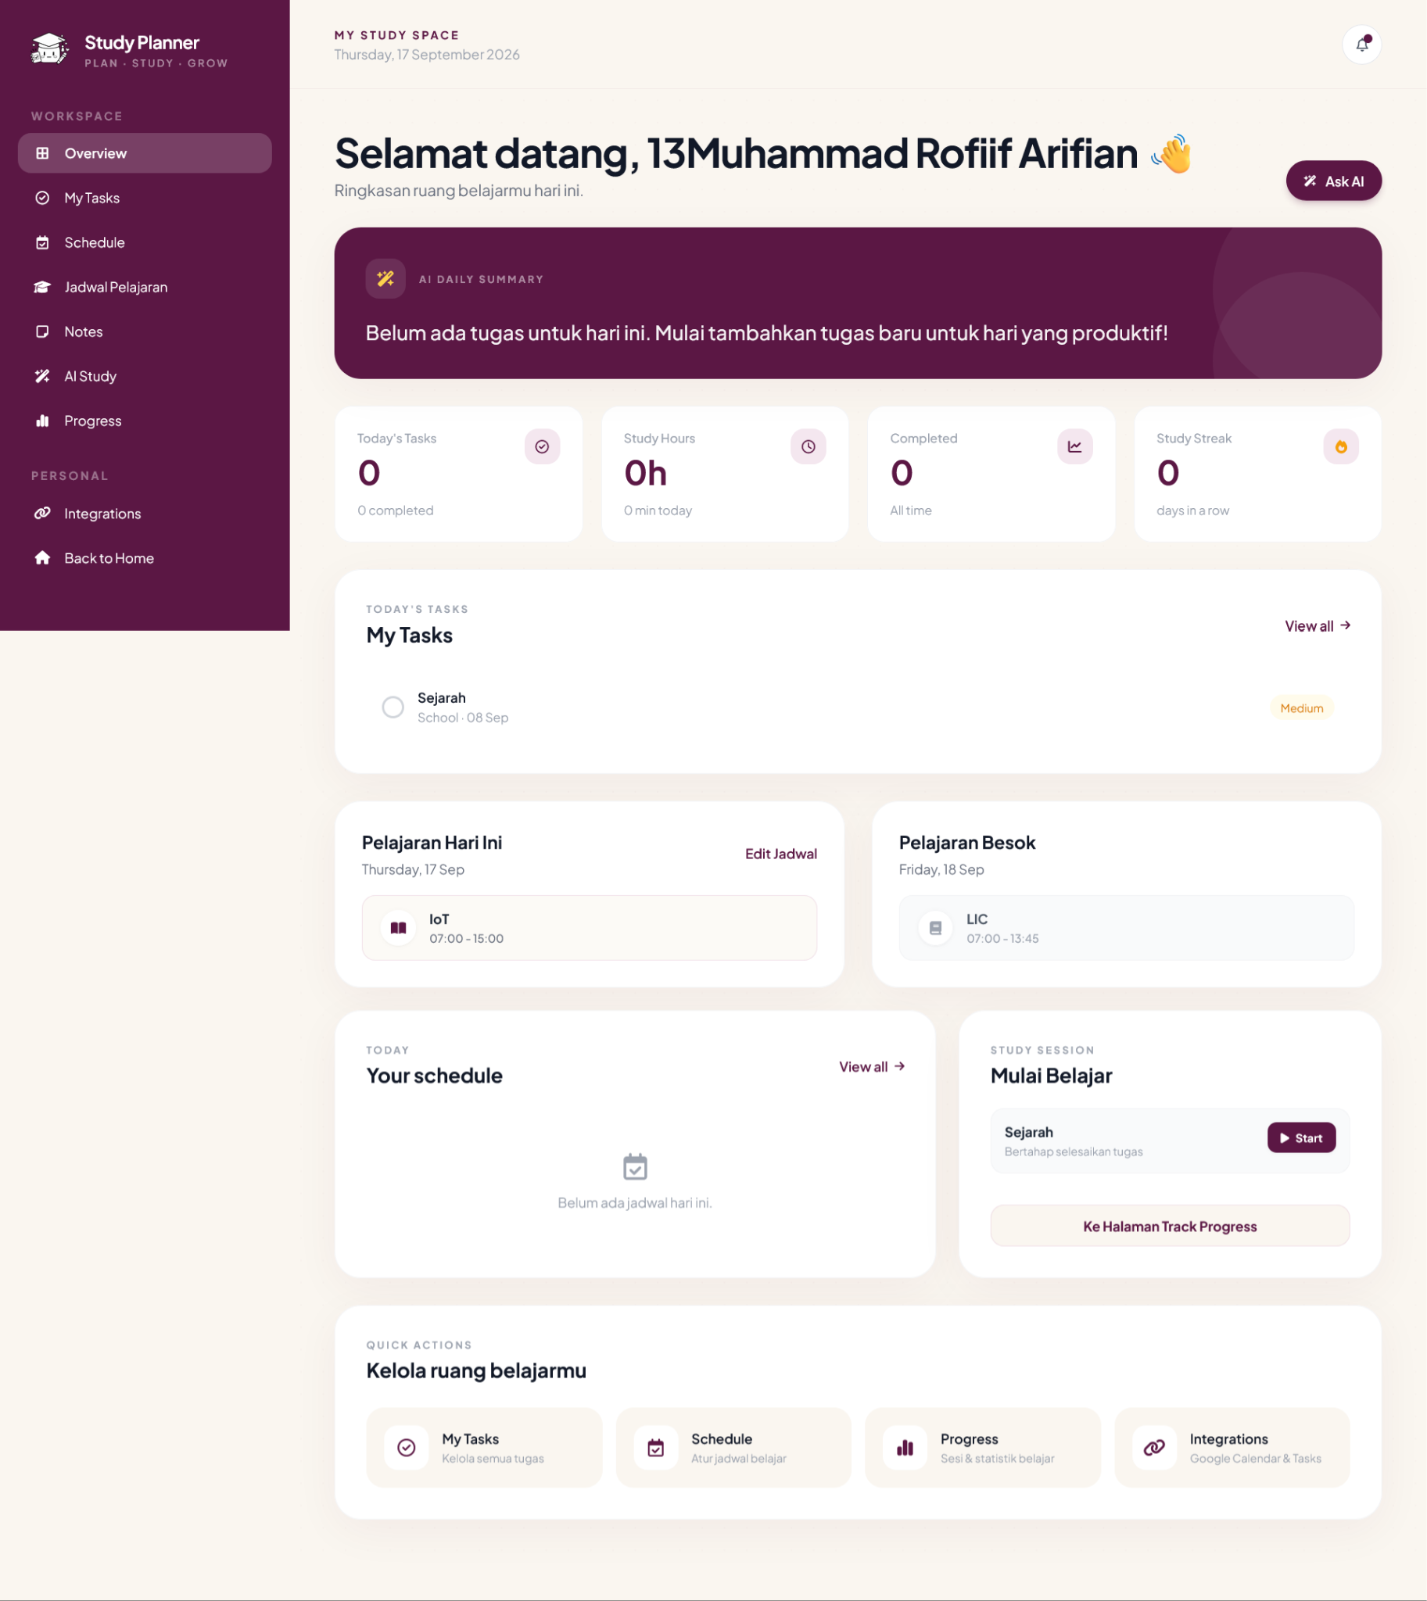
Figure 1: Main Dashboard (Overview Page)
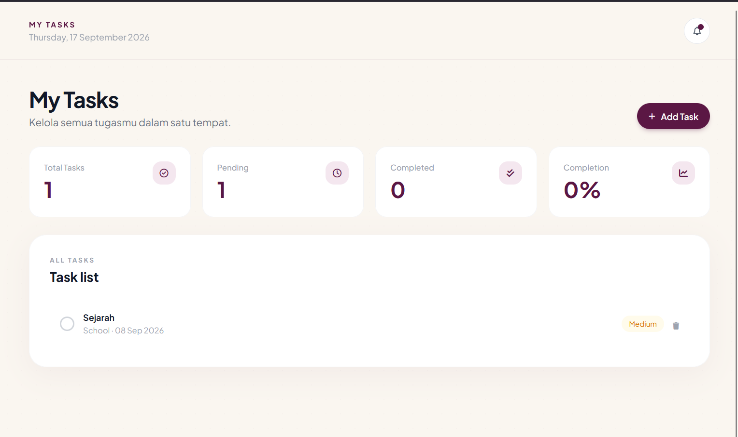
Figure 2: My Tasks Management Page

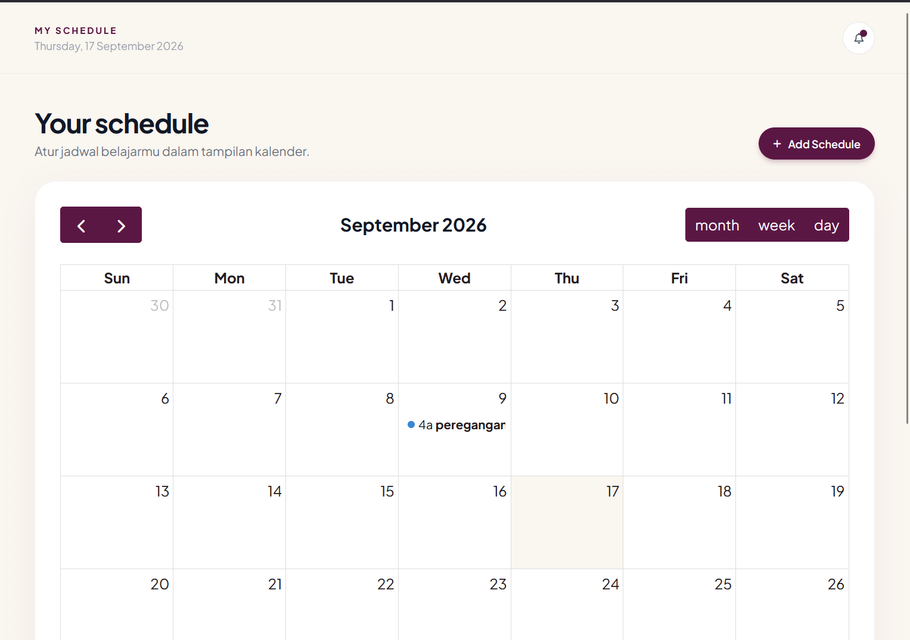
Figure 3: Interactive Calendar (Schedule Page)

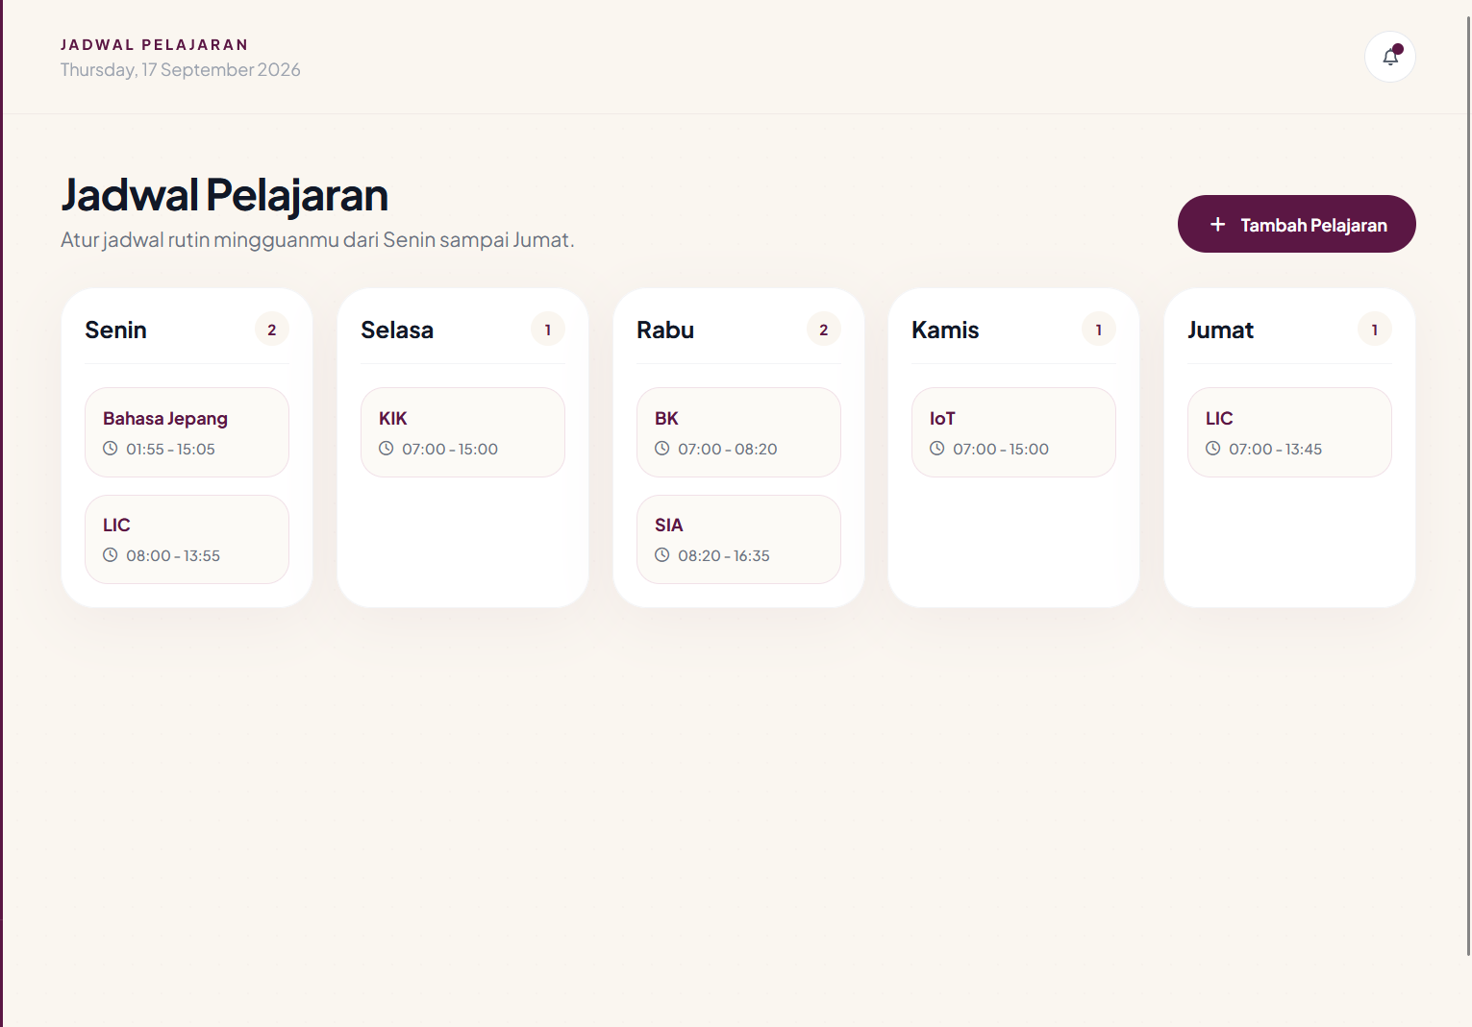
Figure 4: Weekly School Timetable Page

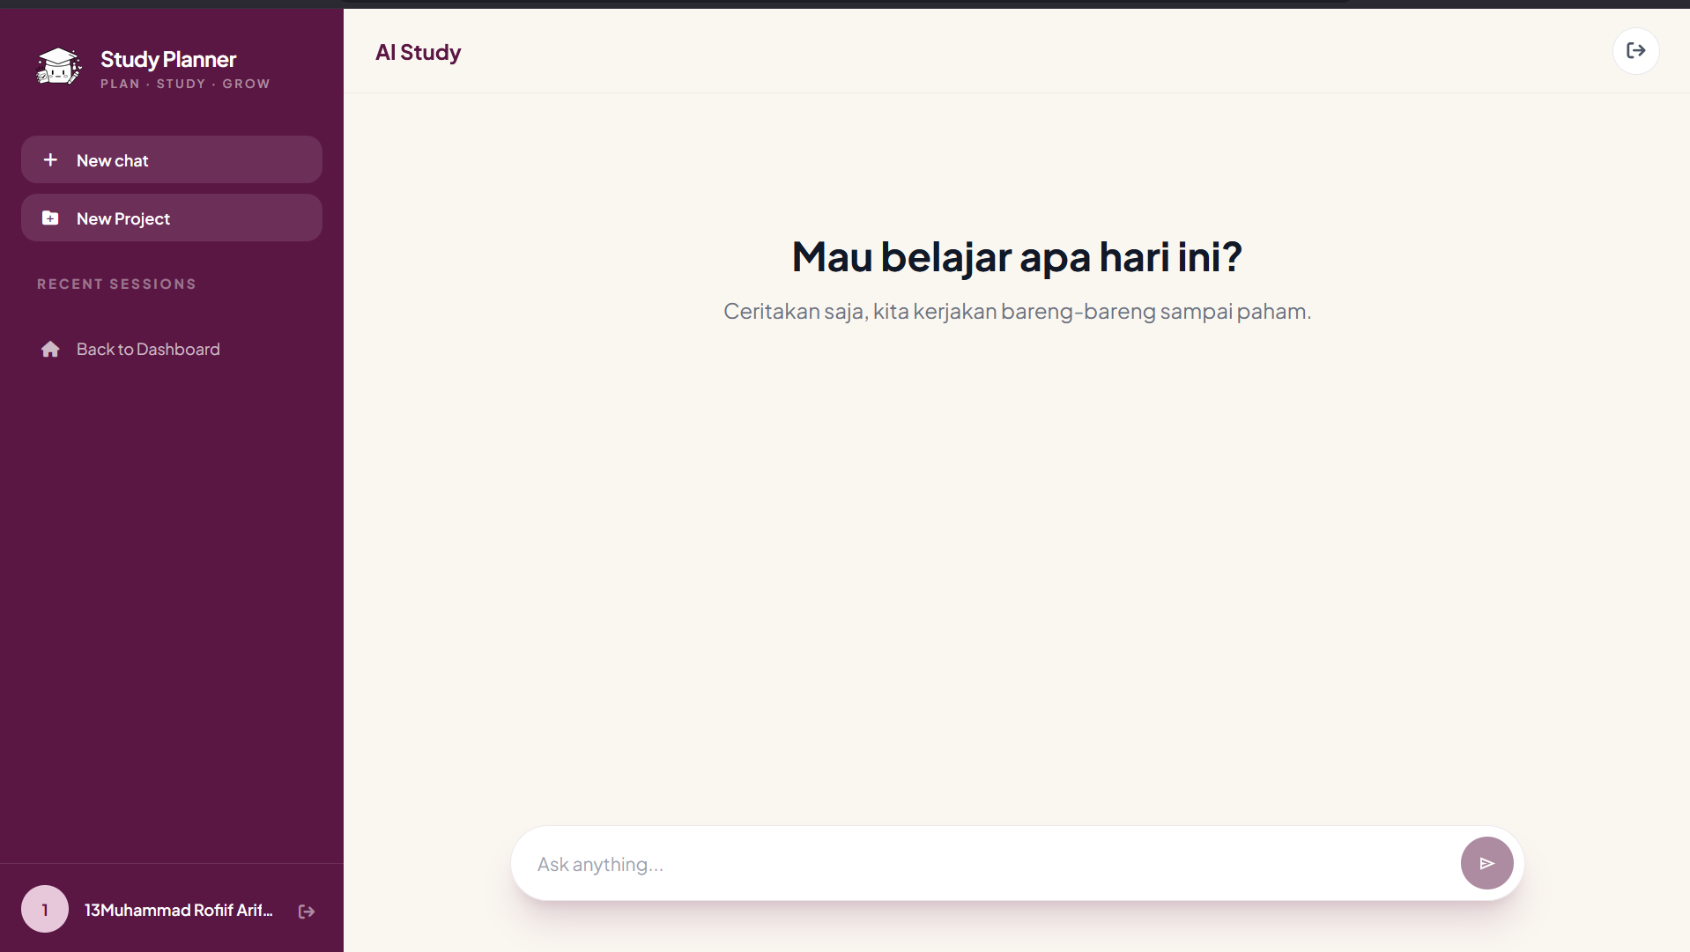
Figure 5: AI Study Virtual Assistant Page

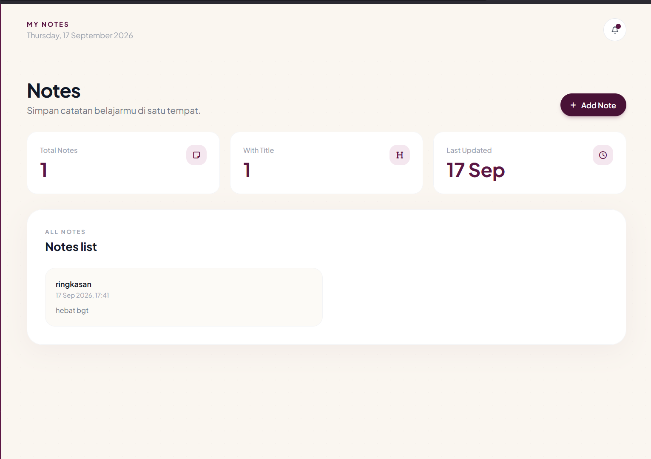
Figure 6: Digital Notes Repository Page

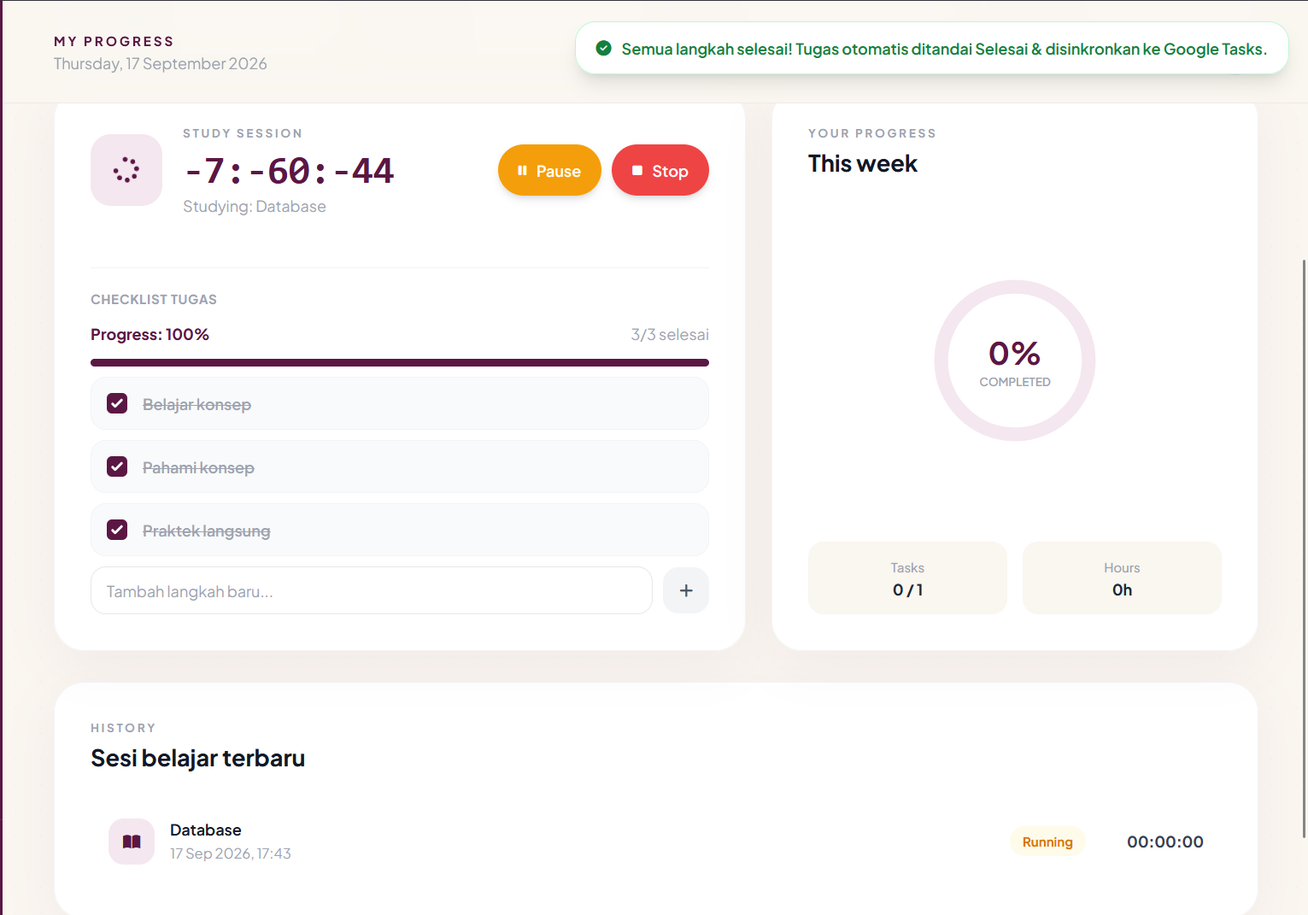
Figure 7: Progress Tracking and Pomodoro Session Page
- DISCUSSION
The empirical findings from the StudyPlanner project provide significant technical insights into the integration of modern web frameworks, cloud APIs, and Large Language Models for student productivity. Utilizing Laravel's Model-View-Controller (MVC) architecture proved essential for maintaining clean domain separation, robust database relational integrity, and built-in protection against standard web vulnerabilities such as SQL injection and Cross-Site Request Forgery (CSRF). Furthermore, solving the problem of application fragmentation by establishing bidirectional synchronization with Google Tasks and Google Calendar significantly reduced the operational friction that students face when managing multiple digital schedules across disparate devices.
The implementation of the AI Study assistant directly within the backend infrastructure (GroqAiService) provides responsive academic support with minimal request latency. By communicating directly with Groq’s high-speed inference engine (qwen/qwen3-8b-27b) via Laravel’s HTTP client, user prompts are processed swiftly without intermediate routing overhead. Managing conversational state natively within relational database tables (chat_sessions and chat_messages) allows the system to construct prompt payloads containing recent message histories and project context while centralizing application logging and error handling under Laravel's native logging architecture.
Despite its operational advantages, the implementation also presented several technical constraints and architectural trade-offs. Because automated action execution (tool calling) is not yet integrated directly into the LLM conversational flow, the background integration endpoints in AiIntegrationController remain separated, meaning the AI assistant functions primarily as an informational tutor rather than an autonomous task scheduler. Additionally, the efficacy of the AI study assistant is inherently tied to student compliance if a user fails to maintain an updated record of active assignments and timetable entries within the database, the context supplied during chat interactions becomes stale, diminishing the personal relevance of the generated academic advice. Despite these limitations, testing data confirms that the platform provides a reliable, secure, and unified productivity ecosystem that bridges traditional planning workflows with modern AI-assisted guidance.

- CONCLUSION
The StudyPlanner project was successfully designed, developed, and tested as an integrated web-based platform to assist high school and vocational students across all departments in managing their academic workflows. By combining a secure MySQL database, robust Laravel backend logic, real-time Google API cloud synchronization, progress tracking modules, and a direct Groq AI tutoring service, the project achieved its primary objectives. The application effectively mitigates the negative impacts of poor time management and disorganized scheduling, providing students with a reliable technological foundation to enhance discipline and academic performance.

- RECOMMENDATION
Based on the technical evaluation and development experience of StudyPlanner, several strategic recommendations are proposed for future enhancements:
- Native Mobile Application Development:
Developing dedicated Android and iOS companion applications using cross-platform frameworks (such as Flutter or React Native) would improve accessibility and allow push notifications to function natively on smartphones.
- Expanded Cloud Ecosystem Support:
Integrating alternative cloud productivity providers (such as Microsoft Graph API for Outlook Calendar and Microsoft To Do) alongside Google services would offer greater flexibility for users utilizing diverse institutional software environments.
- Institutional LMS Integration:
Establishing secure API bridges with standard school Learning Management Systems (LMS) would enable automated gradebook imports, assignment syncs, and direct teacher-to-student task distribution, transforming the project into an enterprise-ready educational tool.

